| **Section 1 – Assessment Task Overview and Description** |
| --- |

# Case Study

You have just decided that you no longer want to work at ‘Huge software development company’ and finally made the decision to update your resume to something a little more modern.

You have mocked up a design using Adobe XD and now have the amazing task of building your design. Please see the design you have finalized below:

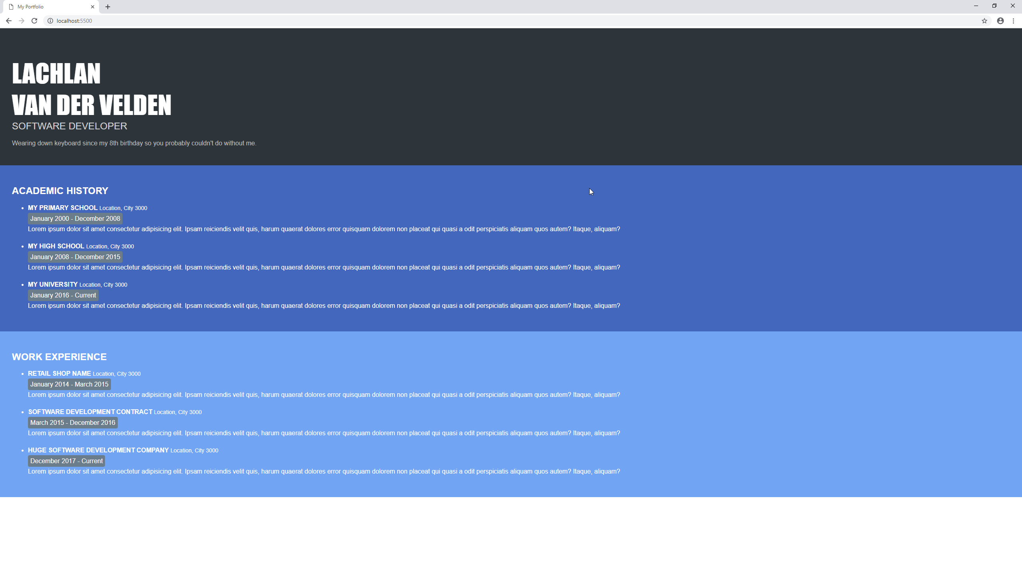

As you have designed this resume yourself, you have been able to select the fonts and colours that you like. The fonts used and color template are as below:

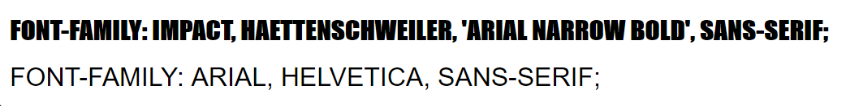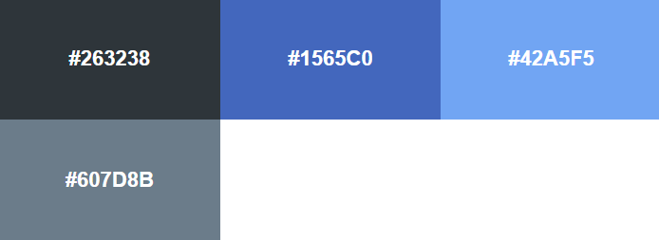

# Student / Class Details

**Full name:** Jackson Soan

**Student ID:** 102698672

**Teacher:** Lachlan Van Der Velden

**Date / Time started:** 15/04/2019 1:30 PM

By checking the box below, you agree that penalties exist for plagiarized work, please refer to the bottom of the document for more information on plagiarism and that all code / work is your own.

I agree and confirm that all work in this assessment is mine

# Tasks

1. Setup your development environment by installing ‘Github Desktop’ and VS Code Live Server.
2. Create a new Github repository called ‘*WebProg_Challenge1_{studentid}*’ (replace {studentid} with your Student ID or First Name eg: WebProgChallenge1_10000100).   
   Please ensure you create this repository as public *or* add ‘*LachlanVelden’* as a collaborator ([See here on how to do this](https://stackoverflow.com/a/55135314))

Click or tap here to enter text.

1. Clone the newly created GitHub Repository with Github Desktop and open in VS Code
2. Build the website using HTML. All CSS must be within a <style> tag or in an external style sheet.  
   Try and replicate the design as perfectly as possible but **with your own information** (made up or real), ask your teacher if you have any concerns if your design is not perfect.
3. Take a full-size screenshot of your final website and *add it to your GitHub repository*.
4. Reflect on your finished website in 25 words or greater for each question
   1. What did you struggle with the most and why?  
      Spacing/size, because it impacts everything else and multiple things can achieve a similar result.
   2. Do you think that you could have done better with more time, why / why not?  
      Just enough time.
   3. How many times did you reference some form of documentation?   
      Quite a few times.
   4. Did you find online Q&A or documentation helped you finish the assessment, why / why not?  
      Yes because I was sketchy on some functions.

| **Section 2 – Assessment Task Submission Information** | |
| --- | --- |
| **Submission Details** | **Due date: 4 Hours from Start Date** |
| 1. The assessment task must be submitted via Canvas or directly to the teacher with an assessment cover sheet. 2. Ensure to fill out:    * your name    * student ID    * your teacher’s name    * the time the assessment was started    * plagiarism agreement 3. Submissions received after the submission date must be approved by your teacher. 4. You have a maximum of 2 attempts at this assessment unless special consideration has been agreed upon with your teacher. |

| **Summary of Evidence to be Submitted / Included** |
| --- |
| * GitHub repository created and linked in this submission |
| * The final website developed as an image (png, jpg, gif) within the GitHub repository |
| * The HTML and CSS code that represents the above screenshot in your GitHub repository |
| * This document with the GitHub URL and a review of your assessment |
|  |
| The task will be assessed as satisfactory when all of the required evidence listed has been satisfactorily demonstrated.  * If applicable, for graded units, the task must be satisfactorily completed before marks will be allocated. Refer to your unit outline for more information. |

| Section 3 – Assessment Task Criteria and Outcome | |
| --- | --- |
| *All items/criteria must be demonstrated satisfactorily to achieve this task. The items/criteria for this activity will be assessed as S – Satisfactory or US – Unsatisfactory.* | |
| Items/criteria | |
| 1. | Demonstrated how to style html elements with CSS |
| 2. | Used at least one of each html tag: div, h1, h2, h3 and p |
| 3. | Used at least 3 CSS selectors |
| 4. | Demonstrated an understanding of the work they produced, and what they struggled with |
|  |  |
|  |  |
|  |  |

|  |  |
| --- | --- |
| **Section 4 – General Assessment Information** | |
| **Decision Making Rules** | Each activity in the assessment task must be satisfactorily completed for the task to be assessed as satisfactory.  Every task must be satisfactorily completed to be assessed as competent in the unit.  *\* For graded units, competence must be demonstrated before a mark can be given.* |
| **Plagiarism** | There are serious penalties for plagiarism that may include repeating a new assessment task or being withdrawn for the unit / course.  Students must ensure that all assessments are their own work (or group work and clearly noted as such).  Please refer to [www.swinburne.edu.au/corporate/registrar/plagiarism/index.html](http://www.swinburne.edu.au/corporate/registrar/plagiarism/index.html) |
| **Reasonable Adjustment** | Students may request reasonable adjustment for assessment tasks.  Reasonable adjustment usually involves varying:   * the processes for conducting the assessment (eg: allowing additional time, varying the venue) * the evidence gathering techniques (eg: oral rather than written questioning, use of a scribe, modifications to equipment)   However, the evidence collected must allow the student to demonstrate all requirements of the unit.  If you have any other issue that may impact your ability to undertake the assessment, please discuss with your teacher. |
| **Re-submission** *(where tasks are not satisfactorily completed)* | Assessment tasks that are not satisfactory can be resubmitted up until the end of the unit as scheduled on the Unit Outline. The timing on this may depend on the equipment required for this assessment task.  Resubmissions received after the scheduled unit end date may not be accepted unless approved by the teacher prior to the end date.  Note: Assessment tasks submitted for the first time after the unit end date as scheduled in the Unit Outline will not be assessed and the student should re-enrol into the unit. |
| **Special consideration** | Students may apply for Special Consideration where personal circumstances have adversely affected their task result or ability to undertake an assessment. A Special Consideration form can be completed prior to, but no later than 3 days after, the date of assessment and submitted to the relevant Manager. |
| **Work Health & Safety** | Activities may require the use of equipment or participation in group exercises. If the teacher identifies any unsafe activity or potentially dangerous situations, the teacher can stop the assessment at any time. |